Operations/Work/Job Activity covered by this assessment: Blasting and Ultrasonic cleaning (Sample)
Required Personal Protective Equipment (PPE) :

Safety glasses must be worn at times. |   Long and loose hair must be scontained.
  Appropriate footwear with substantial uppers must be worn. |   Close fitting/protective clothing to cover arms and legs must be worn.
Respiratory protection devices required. |   Oil free leather gloves and spats must be worn.

Hearing protection must be used when using this machine.

Note : Always use clean transparent plastic gloves while handling the
samples for blasting and ultrasonic cleaning.

Operational Procedure:

Purpose of blasting is to clean and remove oxide layer from the surface.

Check the Work instructions from Supervisor.

Visually inspect the sample to check any deformities like dents, burrs etc.

Mask the job if required as per instructions given by the supervisor.

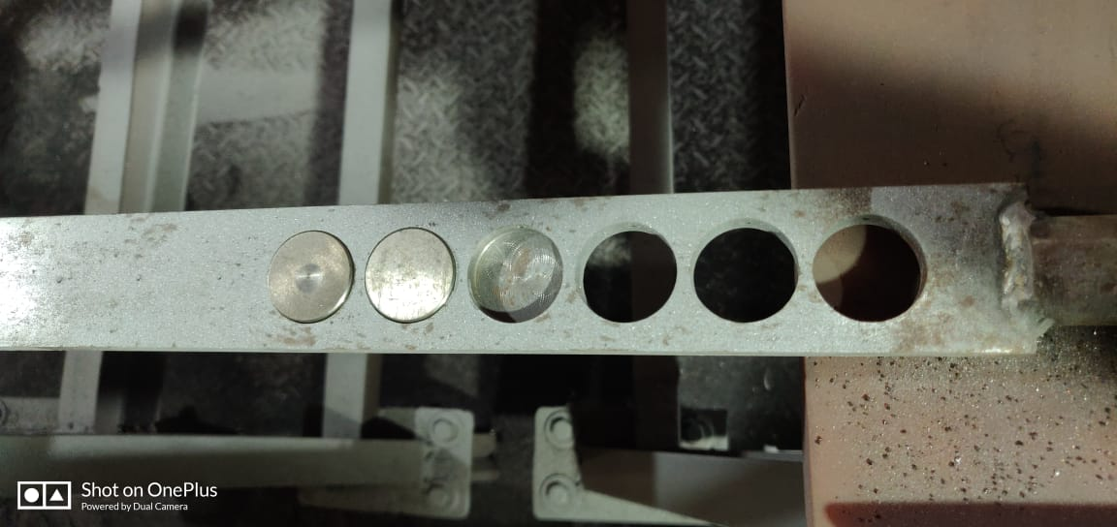
Hold sample in a suitable fixture and handle it carefully [Fig 1].
Fig 1.

Place the fixture horizontally on the metal frame in the blasting area.

Fill the grit tank with 80 grit Alumina powder. Use the Virgin Aluminum Oxide Grit always [Fig 2 –A]

Set the air pressure to 6.5 bar for getting the proper surface roughness.

[Fig 2 –B]
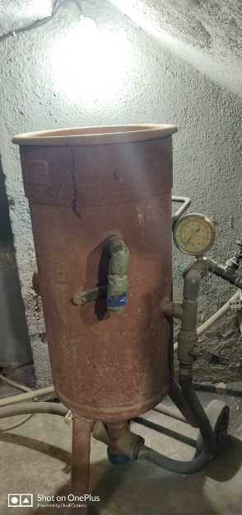
A
B

Fig 2.

Wear a proper mask and blasting helmet before starting the blasting operation. [Fig 3].

Use the 6 mm Nozzle for grit blasting operation. Use go no gauge on nozzle to check fitness of use. Replace nozzle if needed.

Blast the surface at 45⁰ angles and maintain 6” to 8” distance from the job to get desired surface roughness. [Fig 4].

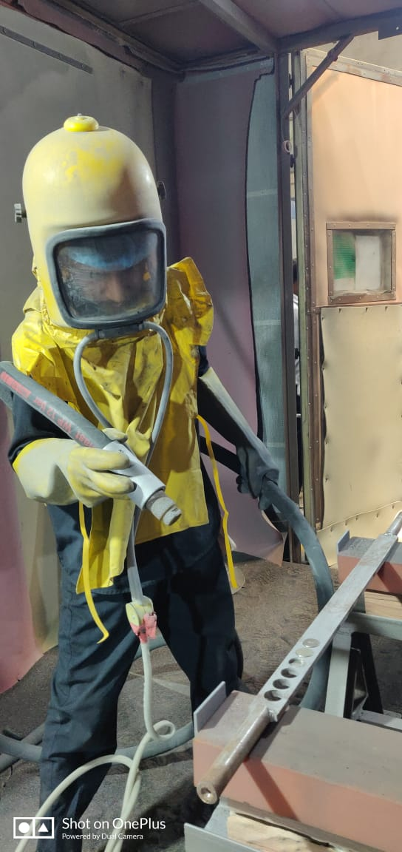
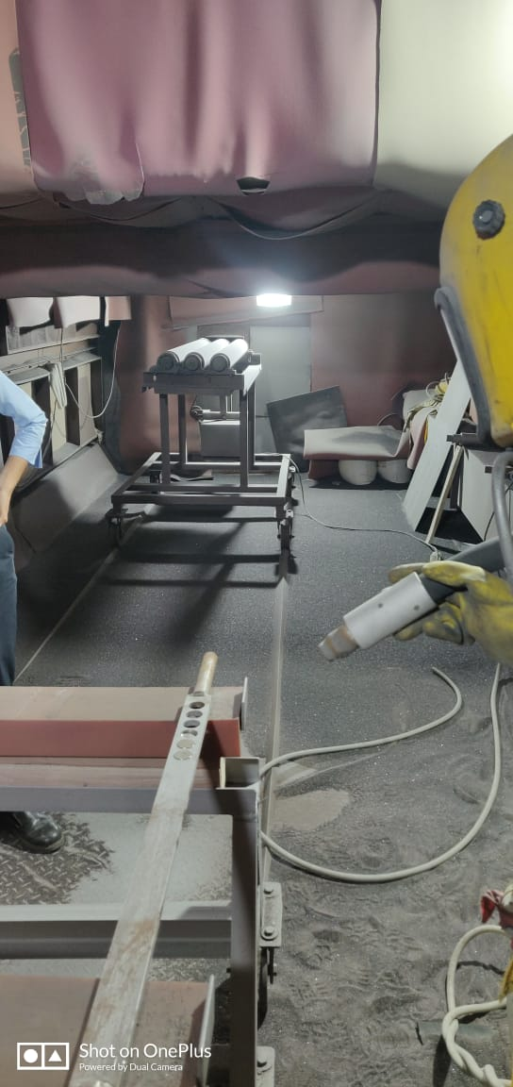

Fig 4.
Fig 3.

Do not over blast the surface, as this will cause entrapping of the grit on blasted surface.

Make sure that the whole surface area of the sample is blasted and no area is left (as per Sa3).

Visually inspect the sample after blasting and ensure that there is no defect.

If the defect is not acceptable, change the sample with a new one.

Blow air over the component after blasting to remove dust.

After final blasting, make sure the surface is uniformly blasted.

Fill the Data Card mentioning the date, grit & pressure for blasting and name of the blasting operator.

Get it approved from the Supervisor.

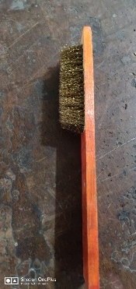
After blasting, clean the surface of the material with soft bristle brush

[Fig 5].
Fig 5.

Clean the Ultrasonic bath with acetone and wipe out the inner chamber with fine tissue paper to remove dust and other particles. [Fig 6]

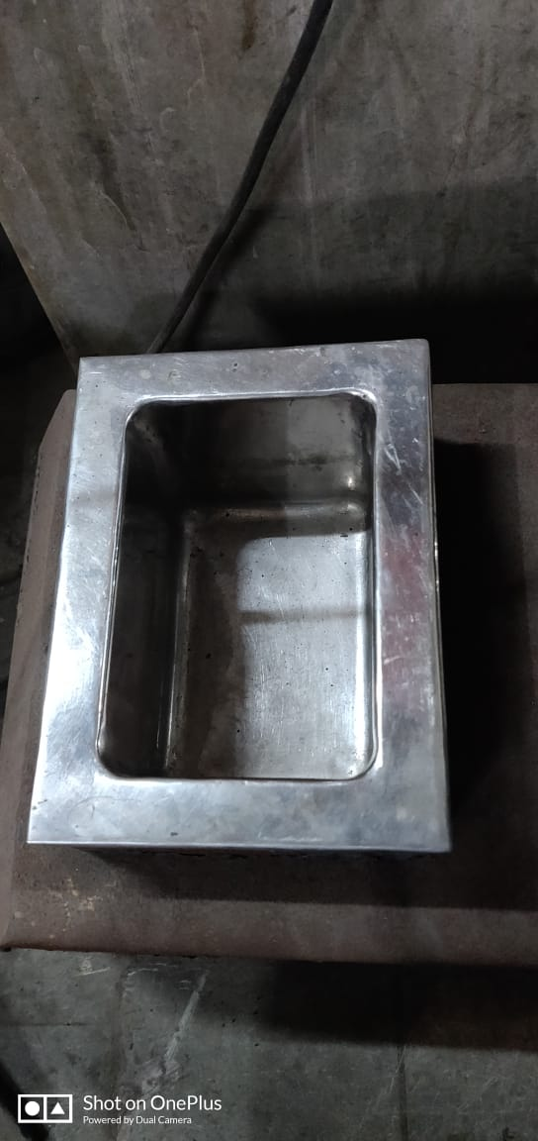
Fill the ultrasonic bath with approx. 250 ml of acetone.

Fig 6.

Place the grit blasted samples inside the ultrasonic bath chamber using Tongs with blasted surface facing upwards.

Start the Ultrasonic bath for 10 minutes so that the blasted surface is cleared of fine grit particles.

Now the ultrasonic cleaned samples is ready for thermal spray coating process.

Assessor : |  | Signature: |  | Date:
Approved: |  | Signature: |  | Date:

